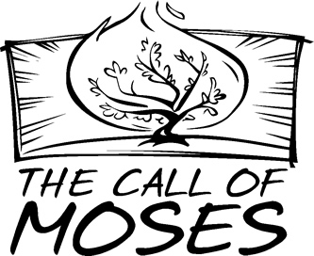

Copyright © Sermons4Kids, Inc.
May be reproduced for Ministry Use
Children’s Worship Bulletin

Moses and the Burning Bush

Exodus 3:1-15

\
Wesley United Methodist Church
3242 Ladson Road
Ladson, SC 29456

Moses and the Burning Bush
Exodus 3:1-15
Copyright © CalvaryCurriculum.com
Used by Permission

Each number represents a letter of the alphabet.
Substitute the correct letter for the numbers to
reveal the coded words.



